How to Order Your Derby Hat
Step One: Measure
How to measure for hat size. Use a cloth tape measure or a piece of ribbon or string and a yardstick. Place tape measure in centre of forehead approx. 2 fingers above eyebrows and measure around head. Repeat - make sure you have same measurements. Approx. 21 - 23 1/2 inches.
Step Two: Choose Blank
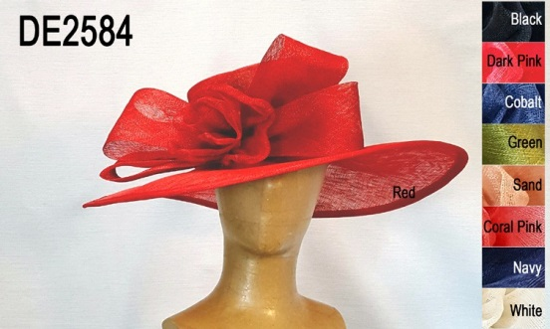
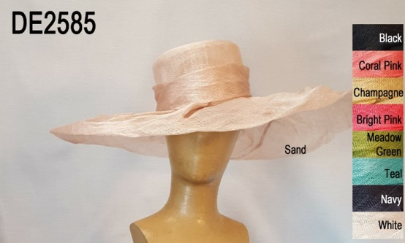
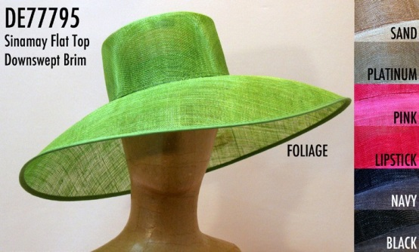

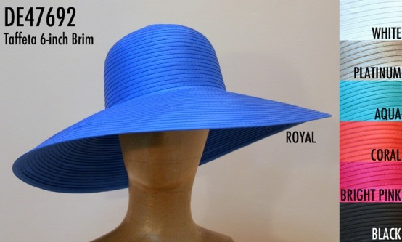
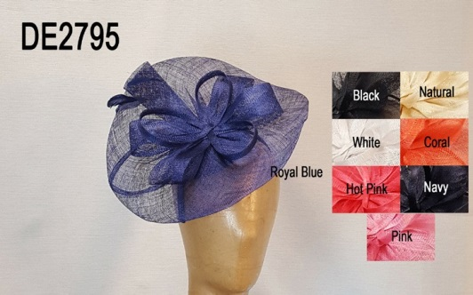
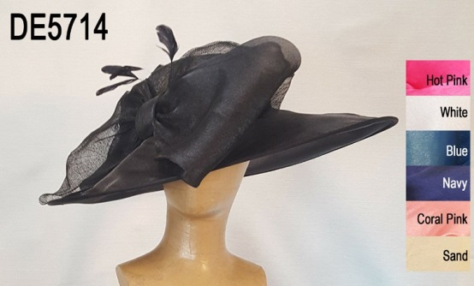

Visit deeshats.com for many more blank hats & fascinators

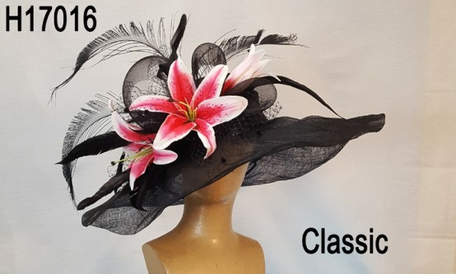
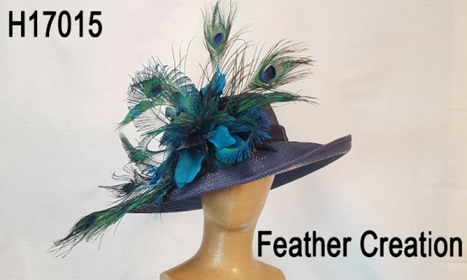
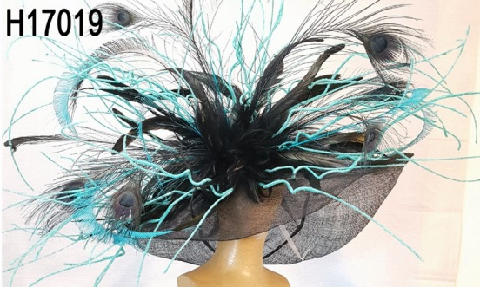
Step 3: Choose Style

Classic

Feather Creation

Fun & Funky

Fascinator
Large Brim
Bright & Fun

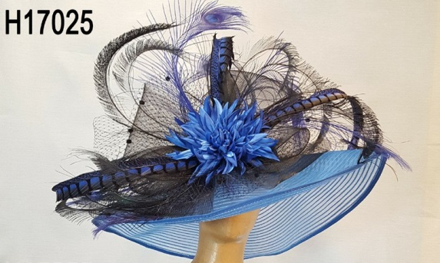
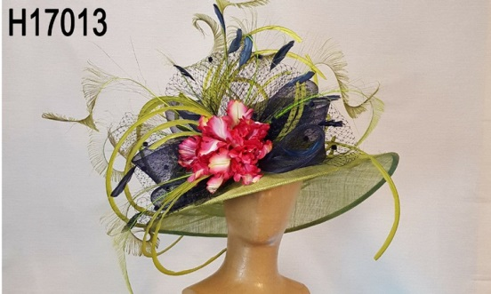
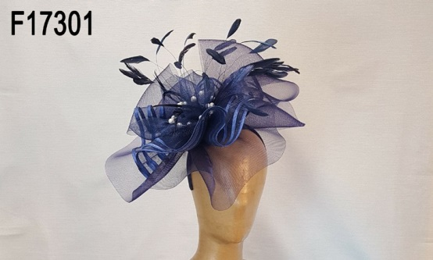
Step Four: Contact Anna or Lorie
We will be available to help you through this process. You can contact us via email: hats@deescrafts.com
or by telephone at (502)896-6755.

